COMMUNICATIONS MODULE INSTANTIATED PHYSICAL ARCHITECTURE

Introduction
This document summarizes the steps and processes used to determine the instantiated physical architecture for the Unmanned Control & Tracking System (UCATS) Communication Module. The process used to determine the instantiated physical architecture of the communication module includes:
- Define the generic physical architecture of the UCATS Communication Module
- Perform Generic Physical Architecture to Functionality Mapping
- Develop a morphological box for the Communication Module using the generic physical architecture as the basis for the proposed instantiated options
- Evaluate infeasibility combinations of the proposed instantiated combinations
- Conduct an Analysis of Alternatives (AoA) for the viable instantiated architecture combinations
- Down-select to final instantiated architecture.

Generic Architecture
Figure 1 summarizes the generic physical architecture for the communications module. This architecture is based on satisfying the UCATS functional allocation. The communication module is composed of:
- Communications Processor: The Communication Processor directs UCATS messages to the transmitter or directs UAV messages to the correct internal UCATS Component.
- Encrypt / Decrypt Module: The UCATS must send and receive encrypted messages. The Encrypt / Decrypt Module receives encrypted UAV messages and decrypts them, and it also receives internal unencrypted UCATS messages and encrypts them; so, they can be transmitted to in-flight UAVs.
- Receiver / Transmitter: The Receiver / Transmitter is the component that receives messages from Unmanned Aerial Vehicles (UAVs), and it forwards UCATS messages to in-flight UAVs.

Figure 1: UCATS Communication Module Physical Architecture
Figure 2 summarizes the UCATS Communication Module Generic Physical Architecture to functionality mapping. As shown in Figure 2, all UCATS communications functions are mapped into the UCATS generic physical architecture.
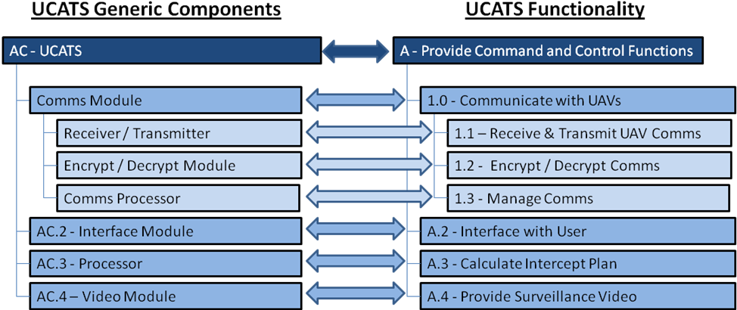
Figure 2: UCATS Communication Module Mapping into UCATS Functions

Instantiated Physical Architecture
A review of medium size UAVs shows that they use both Line-of-Site (LOS) radio communications and Satellite Communications (SATCOMS). Some UAVs use either SATCOM or LOS, and some UAVs use both forms of communication. Those UAVs that perform high endurance Intelligence Surveillance and Reconnaissance (ISR) missions, typically use LOS radios due to the relatively high weight and power required for SATCOM radios. Therefore, the Receiver / Transmitter solution must accommodate both SATCOMS and LOS communications.
UAVs that use SATCOMS communications are more constrained than LOS communications for the UCATS surveillance missions due to the limited bandwidth associated with SATCOMs, which impact the ability to transmit continuous video streams and packet loss during the UAV transmission to the satellite. However, if video surveillance is not required, SATCOM radios should provide adequate communications for UCATS. Additionally, SATCOM radios do provide the best solution for communicating with UAVs in the urban canyons, since LOS communications are easily shielded by buildings, especially when the UCATS is very close to the surveillance UAV and shielding from buildings becomes exaggerate. A major trade-off for the Receiver /Transmitter will involve discovering a means of providing LOS communications despite the shielding caused by buildings in the urban environment.
Trade-offs for the Encrypt / Decrypt Module involves an evaluation of the Commercial-off-the-Shelf (COTS) encryption software versus the use of military grade radios that provide encryption as part of the radio functionality.
The main trade-off for the Communications (Comms) Processor involves determining if this functionality should be combined with the UCATS main processor or split into a separate processor just for communications.

Instantiated Communications Architecture Options
Table 1 summarizes the morphological box for the UCATS instantiated physical architecture. These options were proposed during a brainstorming session with Team DJ3K. The descriptions of these options are provided below. One of the primary criteria used when determining the available options was modularity. The Communications Module is probably the most affected by potential technology upgrades, especially when considering the growth potential in encryption technology, SATCOMs, accurately determining position, and bandwidth. Therefore, it is imperative that all the physical instantiations be as modular as possible to accommodate the probable future upgrades in these technologies.
Comms Processor | Encrypt / Decrypt Module | Receiver / Transmitter
Comms Processor | Encrypt / Decrypt Module | LOS Antennas
Standalone Comms Processor | Software Based | Ground Based Antenna Tower
Integrated UCATS Processor | Integrated with Radio | UAV Based Antenna
 | COTS Encryption Module | Balloon Based Antenna
Table 1: Communications Module Morphological Box

Communications Processor:
The options available for the communication processor include:
- Stand Alone Communications Processor: A stand alone communication processor may be beneficial due to the high rates of data the UCATS Communication Module will need to process because of the UAV video data, which can include five data streams of video.
- Integrate the UCATS communication processor functionality with the UCATS processor: This involves not instantiating a separate processor to address the UAV communications, but instead integrate that functionality with the primary UCATS processor. This is beneficial because it increases the reliability of the UCATS by not introducing another, which could increase the incidence of failures.

Encrypt/ Decrypt Module:
The options available for the Encrypt / Decrypt Module:
- Reside on Communications Processor: This involves having software, which resides on the Communications Processor, perform all encryption / decryption functionality. The benefit of this solution is that the encryption / decryption software can easily be updated as encryption techniques advance.
- Embedded in Radio: This involves buying a radio with encryption capability already integrated into the radio. The benefit of this solution is that the radio and encryption process are tightly integrated and therefore, are less susceptible to incompatibility issues.
- COTS Encryption Module: This involves obtaining a separate encryption module, which is used to perform radio encryption. The benefit of this option is that it would not constrain the radio selection, because selecting a radio with encryption ability would not be necessary.

Receiver / Transmitter:
The down-select to specific radios will be accomplished during the detailed communications module design, which will follow systems design. As discussed above, UCATS will require both LOS radios and SATCOM capabilities. In order to maintain a modular design, which would allow for upgrades if new technology becomes available, these two forms of UAV communication will remain as separate modules. The primary assessment option for the Receiver / Transmitter involves selecting the method used to maintain LOS radio communication with the UAVs, which are known as the LOS antenna options. These options for the LOS antennas include:
- Ground-Based Antenna Tower: This option is a single antenna tower that is capable of providing LOS communications with the UAV. The benefit of this option is that it is one of the more cost effective options.
- UAV-Based Antenna: This option involves having a separate UAV that is used as a communications relay platform. The benefit of this option is that it likely provides the best communication coverage.
- Balloon-Based Antenna: This option involves using a balloon as a communication relay. The benefit of this option is that it provides good communication coverage, but it is not as expensive as the UAV option.

Infeasibility Combinations
There are no infeasibility combinations.

AoA
The down select criteria used for the AoA are based on meeting the UCATS requirements and are assessed using the Stakeholder Value Mapping criteria. Table 2 summarizes the Stakeholder Value Mapping Criteria and how they are applied to the down select criteria of the Communications Module Physical Instantiated Architecture.
NEED  # | STAKEHOLDER VALUE MAPPING CRITERIA | STAKE-HOLDER RELATIVE WEIGHT | WHAT THIS MEANS WHEN ASSESSING THE COMMUNICATION MODULE ARCHITECTURE
1 | Accuracy: The accuracy of information the UCATS provides. | 53 | The Comms Module maintains communication with the UAV(s).
2 | Affordability: A cost-effective solution to command and control UAVs. | 32 | The Comms Module has a low unit and support cost.
3 | Safety: Safety of personnel and the urban community. | 45 | The Comms Module maintains communication with the UAV(s).
4 | Security: Communication and operational security. | 50 | The Comms module sends encrypted signals.
5 | Reliability: Reliability is the probability the UCATS will function as designed without failures and/or outages. | 47 | The Comms Module is reliable.
6 | Maintainability: To keep the UCATS in good repair. | 31 | The Comms Module is easy to maintain.
7 | Transparency of Operations: The ability to “see” how the UCATS components are functioning. | 19 | N/A. The Comms Module does not interface with the operator.
8 | Usability: How easy the UCATS is to use. | 51 | N/A. No operator interface.
9 | Availability: How often UCATS is available for use. | 52 | The Comms Module is reliable and easy to repair.
10 | Interoperability: How easy it is for UCATS and UAVs to exchange information and use the information that has been exchanged. | 52 | The Comms Module maintains communication with the UAV(s).
11 | Portability: How readily transportable the UCATS C2 station from one location to another. | 33 | The Comms Module is easy to transport.
12 | Reproducibility: The ability for UCATS to generate the same outputs given identical inputs. | 41 | N/A.
13 | Performance: UCATS will perform according to the design. | 53 | The Comms Module will meet the SRS.
14 | Flexibility: The ability of the UCATS design to adapt when external changes occur. The ease with which the UCATS can respond to uncertainty in a manner to sustain or increase its value delivery. | 47 | The Comms Module shall be capable of adapting to external changes.
15 | Extensibility: The ability of the UCATS design and implementation to take into consideration future growth. A systemic measure of the ability to extend the UCATS and the level of effort required to implement the extension. | 47 | The Comms Module will be capable of easily integrating new technology. Therefore, modular designs are highly desirable.
Table 2: Communication Module Applicable Stakeholder Value Mapping Criteria
Table 3 summarizes the applicable evaluation criteria for the Communication module, the relative weights, and the normalized weights, which are specific for the Communication Module evaluation.
APPLICABLE CRITERIA | NEED - (RELATIVE WEIGHT) |  |  | NORMALIZED RELATIVE WEIGHT
APPLICABLE CRITERIA | NEED # | RELATIVE WEIGHT | Total Relative Weight | NORMALIZED RELATIVE WEIGHT
The Communications Module maintains communication with the UAV(s). | 1 | 53 | 100 | 0.199
 | 3 | 47 | 100 | 0.199
The Communications Module has a low unit cost. | 2 | 32 | 32 | 0.064
The Communications Module has a low support cost. | 2 | 32 | 32 | 0.064
The Communications module sends encrypted signals. | 4 | 50 | 50 | 0.099
The Communications Module is reliable. | 5 | 47 | 47 | 0.093
The Communications Module is easy to maintain. | 6 | 32 | 32 | 0.064
The Communications Module is easy to repair. | 6 | 31 | 83 | 0.165
The Communications Module is easy to repair. | 9 | 52 | 83 | 0.165
The Communications Module is easy to transport. | 11 | 33 | 33 | 0.066
The Comms Module shall be capable of adapting to external changes. | 14 | 47 | 47 | 0.093
The Comms Module will be capable of easily integrating new technology. Therefore, modular designs are highly desirable. | 15 | 47 | 47 | 0.093
Total | 503 |  |  | 1.000
*Normalized Relative Weight = ∑(of Applicable Need Weights for that Criteria)/ ∑(of All Applicable Need Weights)
Table 3: Communications Module Evaluation Criteira and the Normaized Weights

Comms Processor
Table 4 summarizes the evaluation criteria that are applicable for the Communications Processor.
APPLICABLE CRITERIA | NORMALIZED RELATIVE WEIGHT | COMMENTS | EVALUATION WEIGHTING*
The Communications Module maintains communication with the UAV(s). | 0.199 | The processor has the available processing power needed to maintain communications. | 0.559
The Communications Module has a low unit cost. | 0.064 |  | 0.180
The Communications Module has a low support cost. | 0.064 | N/A – The processor does not impact support costs.
The Communications module sends encrypted signals. | 0.099 | N/A - The Processor does not affect encryption capability.
The Communications Module is reliable. | 0.093 |  | 0.261
The Communications Module is easy to maintain. | 0.064 | N/A – The Processor is not a maintainable item.
The Communications Module is easy to repair. | 0.165 | N/A – The Processor is not a repairable item.
The Communications Module is easy to transport. | 0.066 | N/A – The processor does not impact transportability.
The Comms Module shall be capable of adapting to external changes. | 0.093 | N/A – Both processor options have equivalent ability to adapt to external changes.
The Comms Module will be capable of easily integrating new technology. Therefore, modular designs are highly desirable. | 0.093 | N/A – Both processor options have equivalent ability to integrate new technologies.
Total Applicable Weight | 0.356 |  | 1.000
*Evaluation Criteria = Applicable Normalized Weight for that Criteria)/ ∑(of All Applicable Normalized Weights)
Table 4: Communications Processor Evaluation Criteria
The scoring for these criteria is:
- Processing Power Needed to Handle UAV Data: Again this is a qualitative assessment. A score of 10 is given if the system can easily handle the processing requirements and a score of 1 is given if it would have difficulty.
- Unit Cost: Based on an internet search, typical high end processors cost less than $2,000 to $3,000; therefore a processor option that costs less than $2,000 scores a 10. A processor option that costs more than twice the maximum high end processor costs scores a 1. Based on this logic, the scoring is computed as follows:
  - Processor option that costs ≤$2,000 receives a 10.
  - A processor that costs between $2,000 and $6,000 is scored as follows:
Score = (Processor Cost - $6,444.44)/(-$444.44)
(This formula assumes a linear relationship between cost and score.)
  - Processor Option that costs ≥ $6,000 receives a 1
- System Reliability: Since both the Comms and the UCATS processor will likely be the same processor, the reliability discussion focuses more on how the reliability is affected by the processor combinations. A score of 10 is given for what is considered a highly reliable system, and a score of 1 is given for an unreliable system. This is a qualitative versus a quantitative assessment because the exact reliability numbers for processors are difficult to discern since they are typically closely guarded by the manufacturer.
Table 5 summarizes the scoring for the processors. A detailed assessment of the comms processors is:
- Stand Alone Processor. The stand alone processor had a score of 10 for processing power, since it is dedicated just to communication. The stand alone processor had a cost score of 5.5. A review of the top processors shows that a high end six core processor costs around $2,000. This is assumed to be the worst case (highest costing) option. If the stand alone processor option is chosen, then UCATS would require one processor for communications and one for the rest of the UCATS functionality, which would result in a worst case cost of $4,000, and based on the formula above, this yields a score of 5.5. The stand alone processor had a reliability score of 9.5. Processors are typically very reliability, especially compared to the MTBF and A_{o} cited in the UCATS requirements. However, the addition of another serial component, even though it is highly reliable, would slightly reduce the overall system reliability.
- Combine UCATS Processor. The combined UCATS processor had a score of 9 for processing power, since it must share the work for all UCATS processing functions; however, most modern processors should be able to handle that processing load. The combined processor had a cost score of 10. The worst case (highest) cost for a high end six core processor is about $2,000. The combined processor would have a reliability score of 10. Since it does not include any additional components, it is the best option for reliability.
Table 5: Comms Process Evaluation
Based on the processor evaluation, the best option is to combine the Comms Processor with the primary UCATS processor. This option has the lowest cost and best reliability. Also, most modern processors should be capable of addressing the Comms requirements along with the other UCATS functionality.

Encrypt / Decrypt Module
Table 6 summarizes the evaluation criteria that are applicable for the Communications Processor. It is assumed all the options can provide the required encryption requirements; so, the evaluation is primarily based on the cost and desired capability.
APPLICABLE CRITERIA | NORMALIZED RELATIVE WEIGHT | COMMENTS | EVALUATION WEIGHTING*
The Communications Module maintains communication with the UAV(s). | 0.199 | N/A - The Encryption Module should not impact the ability of the Comms Module to communicate.
The Communications Module has a low unit cost | 0.064 |  | 0.157
The Communications Module has a low support cost. | 0.064 |  | 0.157
The Communications module sends encrypted signals. | 0.099 | N/A – It is assumed this is equivalent for all the options.
The Communications Module is reliable. | 0.093 |  | 0.229
The Communications Module is easy to maintain. | 0.064 | N/A – The Encryption Module is not a maintainable item.
The Communications Module is easy to repair. | 0.165 | N/A – The Encryption Module is not a repairable item.
The Communications Module is easy to transport. | 0.066 | N/A – The Encryption Module does not impact transportability.
The Comms Module shall be capable of adapting to external changes. | 0.093 |  | 0.229
The Comms Module will be capable of easily integrating new technology. Therefore, modular designs are highly desirable. | 0.093 |  | 0.229
Total Applicable Weight | 0.407 |  | 1.000
*Evaluation Criteria = Applicable Normalized Weight for that Criteria)/ ∑(of All Applicable Normalized Weights)
Table 6: Encrypt/Decrypt Module Evaluation Criteria
The scoring for these criteria is:
- Unit Cost: Based on an internet search, the least expensive encryption option is to use a COTS software product with a high end cost of $400. So, an Encryption / Decryption option with a unit cost less than $400 scores a 10. At the higher end, a military grade radio, such as a SINGAR costs $6,500. A standalone Encryption / Decryption Module costs $2,000. Therefore, if any Encryption / Decryption option costs more than $8,500 (The sum of the SINGARS and Encryption Module), it receives a score of 1. This truly represents the high end since the SINGARS radio already comes with encryption capability. Based on this logic, the scoring is computed as follows:
- Encryption / Decryption option that costs ≤$400 receives a 10.
- An Encryption / Decryption option that costs between $400 and $8,500 is scored as follows:
Score = (Encrypt / Decrypt Option Cost - $9,400)/(-$900)
(This formula assumes a linear relationship between cost and score.)
  - Encryption / Decryption Option that costs ≥ $8,500 receives a 1
- Support Cost: It is desirable that it cost less than 1 man week / year to support the Encryption / Decryption Module. Assuming a man-hour cost of $200 / hour equates to $8,000 / year. So, an Encryption / Decryption option with a support cost less than $8,000 / year scores a 10. At the higher end if it requires more than 10 man-weeks / year or $80,000 / year to support the Encryption / Decryption Module, it receives a score of 1. This truly represents the high end since the SINGARS radio already comes with encryption capability. Based on this logic, the scoring is computed as follows:
- Encryption / Decryption option that has a support costs ≤$8,000 receives a 10.
- An Encryption / Decryption option that costs between $8,000 and $80,000 is scored as follows:
Score = (Encrypt / Decrypt Option Cost - $88,000)/(-$8,000)
(This formula assumes a linear relationship between cost and score.)
  - Encryption / Decryption Option that costs ≥ $80,000 receives a 1
- Reliability: This is a qualitative assessment because reliability information for radios and encryption devices is hard to obtain and is closely guarded by the manufacturers. Instead, the reliability assessment addresses the impact of the solution on reliability. A score of 10 is given for what is considered a highly reliable system, and a score of 1 is given for an unreliable system.
- Flexibility: This is a qualitative assessment. A score of 10 is given for a solution that can easily adapt to external changes, and a score of 1 is given for a solution that is very difficult to adapt to external changes.
- Extendibility: This is a qualitative assessment. A score of 10 is given for a solution that can easily be upgraded to the latest encryption technology, and a score of 1 is given for a solution that is very difficult to upgrade.
Table 7 summarizes the scoring for the Encryption/Decryption Module. A detailed assessment of the Encryption/Decryption Module is:
- Software Based. The unit cost had a score of 10. Per an internet search, off the shelf software costs around $400. The software based encryption solution had a support score of 7.6. The support costs are primarily based on the UCATS software modifications that may be needed if there is an interface problem between the UCATS software and encryption software. Assuming there are two software problems that require fixing during the life of UCATS, it equates to the following costs:
  - Cost to fix Problem: 1 programmer for 1 week (40 hours) = $8,000
  - Cost to Test Problem: 1 programmer for ½ week (20 hours) = $4,000
  - Cost to Re-install on UCATS: 1 programmer for one day = $1,600
  - Cost / Problem = $13,600.
Therefore, total support costs are $27,200.
This solution had a reliability of 10, since it did not add any additional components to UCATS. The flexibility score was 6, since it would require software modifications to adapt to external changes, and it had an extendibility score of 6, since it would also require software modifications to adapt to new technology.
- Integrated with Radio. The unit cost had a score of 3.22, since the unit cost of a SINGARS radio (per internet search) is about $6,500. The integrated radio had a support cost score of 10. The likely solution for a problem would be to replace the radio, which typically costs around $6,500 (Based on SINCGARS Radio Costs). Even if this happened once a year, which is unlikely, based on the SINGAR radio MTBF is over 5000 hours). The yearly cost would not exceed $6,500/year. This solution had a reliability of 10, since it did not add any additional components to UCATS. The solution had a flexibility score of 8. The SINGARS radio is very flexible. The solution could be scalable by buying a new radio, but it would require recoding of the interfaces. The scalability score was 6.
- COTS Encryption Module (Hardware Module): The unit cost had a score of 7.11, since the unit cost of an Encryption / Decryption Module (per internet search) is about $2,000 and the cost of a radio for UAVs without encryption gear capability is about $1,000 (Per internet search). The integrated radio had a support cost score of 10. The likely solution for a problem would be to replace the Encryption / Decryption Module, which typically costs around $2,000. ). Even if this happened once a year, which is unlikely, based on the SINGAR MTBF projections. The yearly cost would not exceed $2,000/year. This solution had a reliability of 8, since it added another component to UCATS. The solution is very flexible by buying a new module, and it would not require recoding of the interfaces, since it interfaces directly with the radio and not UCATS software. The flexibility score was 10. The solution could be scalable by buying a module, and it would not require recoding of the interfaces, since it interfaces directly with the radio and not UCATS software. The scalability score was 10.
Table 7: Encrypt / Decrypt Module Evaluation
Based on the Encrypt / Decrypt Module evaluation, the best option is the COTS Encryption Module. It had good support and unit costs. It was the most scalable, and it had acceptable reliability.

Receiver / Transmitter
Table 8 summarizes the evaluation criteria that are applicable for the Receiver / Transmitter, specifically the LOS antenna. The UCATS will use separate SATCOM and LOS radios. The use of either SATCOM or LOS radios is dependent on the radios installed on the UAVs being used for surveillance. The LOS antenna is required to maintain LOS communications between UCATS and the UAV in urban areas.
APPLICABLE CRITERIA | NORMALIZED RELATIVE WEIGHT | COMMENTS | EVALUATION WEIGHTING*
The Communications Module maintains communication with the UAV(s). | 0.199 | N/A - The Encryption Module should not impact the ability of the Comms Module to communicate. | 0.221
The Communications Module has a low unit cost. | 0.064 |  | 0.071
The Communications Module has a low support cost. | 0.064 |  | 0.071
The Communications module sends encrypted signals. | 0.099 | N/A – It is assumed this is equivalent for all the options.
The Communications Module is reliable. | 0.093 |  | 0.103
The Communications Module is easy to maintain. | 0.064 | N/A – The Encryption Module is not a maintainable item. | 0.071
The Communications Module is easy to repair. | 0.165 | N/A – The Encryption Module is not a repairable item. | 0.183
The Communications Module is easy to transport. | 0.066 | N/A – The Encryption Module does not impact transportability. | 0.073
The Comms Module shall be capable of adapting to external changes. | 0.093 |  | 0.103
The Comms Module will be capable of easily integrating new technology. Therefore, modular designs are highly desirable. | 0.093 |  | 0.103
Total Applicable Weight | 0.901 |  | 1.000
*Evaluation Criteria = Applicable Normalized Weight for that Criteria)/ ∑(of All Applicable Normalized Weights)
Table 8: LOS Antenna Evaluation Criteria
The scoring for these criteria is:
- Maintain Communications: Team DJ3K assumed Boston represented a typical urban area. The tallest building in Boston is 910 feet. If the LOS antenna solution can communicate with the surveillance UAV even when a 910 foot building shields the UCATS from the UAV, it receives the maximum score of 10. If the LOS antenna cannot communicate with the UAV, even when it is shielded by a relatively small building of less than 100 feet, it received a score of 1. Based on this logic, the scoring is computed as follows:
- LOS Antenna options that are not compromised when shielded by buildings ≥ 910 feet, receive a 10.
- LOS Antenna options not shielded by buildings between 910 feet and 100 feet are scored as follows:
Score = (Building Height that shields a LOS Antenna option – 10 feet)/(90 feet)
(This formula assumes a linear relationship between shielding and score.)
  - LOS Antenna options that are compromised when shielded by buildings ≤ 100 feet receives a 1.
- Unit Cost: A 1,000 foot ground based antenna costs $390,000. Assuming this is the nominal cost of an antenna, ideally, the unit cost would be ¼ of this cost. Therefore, an antenna that has a unit cost of $97,500 receives a 10. Conversely, if the antenna cost more than four times this cost, which is $1,560,000, receives a 1. Based on this logic, the scoring is computed as follows:
- Antenna option that costs ≤$97,500 receives a 10.
- An Antenna option that costs between $97,500 and $1,560,000 is scored as follows:
Score = (Antenna Cost - $2,166.67)/(-$162,500)
(This formula assumes a linear relationship between cost and score.)
  - Encryption / Decryption Option that costs ≥ $1,560,000 receives a 1
- Support Cost: It is desirable that it cost less than 1 man week / year to support the Antenna. Assuming a man-hour cost of $200 / hour equates to $8,000 / year. So, an Antenna option with a support cost less than $8,000 / year scores a 10. At the higher end if it requires more than 10 man-weeks / year or $80,000 / year to support the Antenna, it receives a score of 1. Based on this logic, the scoring is computed as follows:
- Antenna option that has a support costs ≤$8,000 receives a 10.
- An Antenna option that costs between $8,000 and $80,000 is scored as follows:
Score = (Antenna Option Cost - $88,000)/(-$8,000)
(This formula assumes a linear relationship between cost and score.)
  - Antenna Option that costs ≥ $80,000 receives a 1
- Reliability: This is a qualitative assessment because reliability information for the LOS antenna options is hard to obtain and closely guarded by the manufacturers. A score of 10 is given for what is considered a highly reliable system, and a score of 1 is given for an unreliable system.
- Maintenance: This is a qualitative assessment, because maintenance information for the LOS antenna options is hard to obtain. A score of 10 is given to a system that is considered easy to maintain, and a score of 1 is given to a system that is hard to maintain.
- Easy to Repair: This is a qualitative assessment, because repair information for the LOS antenna options is hard to obtain. A score of 10 is given to a system that is considered easy to repair, and a score of 1 is given to a system that is hard to repair.
- Transportability: This is a qualitative assessment. A score of 10 is given to a system that can be transported very easily, and a score of 1 is given to a system that is hard to transport.
- Flexibility: This is a qualitative assessment. A score of 10 is given for a solution that can easily adapt to external changes, and a score of 1 is given for a solution that is very difficult to adapt to external changes.
- Extendibility: This is a qualitative assessment. A score of 10 is given for a solution that can easily be upgraded to the latest antenna technology, and a score of 1 is given for a solution that is very difficult to upgrade.
- Ground Based Antenna Tower: Table 9 summarizes the Ground Based Antenna individual Scoring.
Criteria | Assessment | Score
Maintain Communications | To meet the transportability option, the ground based antenna needed to be mobile. An internet search of companies that provide mobile radio antennas shows that the typical maximum height of mobile antennas is about 150 feet. As shown in Appendix A, the tower antenna cannot communicate with UAVs when buildings higher than 497.8 feet are in the way. | 5.4
Unit Cost | Unit Cost of Antenna Tower: ~$7,000 (Internet search of companies offering mobile antennas)  Trailer Cost: ~$5,000. The antenna will need a trailer capable of transporting all the parts. The unit cost is based on an internet search of trailers capable of hauling the antenna. (~10 foot long).  Total Cost: $7,000 + $5,000 = $12,000 | 10
Support Cost | Training Costs: ~2 hours @ $100 / hour = $200. This assumes limited training needed to teach the operator how to assemble and disassemble the antenna. | 10
Reliability | The antenna tower should have good reliability. | 9
Maintenance | The antenna tower maintenance requirements are limited to inspecting the components and maintaining the trailer. | 9
Easy to Repair | The antenna tower would not be easy to repair. It would require possible machining of new parts. | 3
Transportability | Even with the trailer, there would be moderate difficulty transporting the antenna tower. | 4
Flexibility | It should be fairly easy to adapt to external changes. | 9
Extendibility | It should be fairly easy to upgrade the antenna; however, a taller tower will likely require a new trailer. | 7
Table 9: Ground Antenna Assessment
- UAV-Based Antenna: Table 10 summarizes the Ground Based Antenna individual scoring. It is assumed the UAV antenna has the same ability for autonomous control and flight planning as the surveillance UAVs. Therefore, the UCATS should be able to direct the UAV antenna to the correct orbit, and an operator will not be required to continuously fly the UAV.
Criteria | Assessment | Score
Maintain Communications | If the communication relay UAVs flew directly over the UAV performing surveillance operations, then the communication relay UAV would continuously maintain communications with UCATS. However, this is cost prohibitive. It is assumed only one UAV acts as a communication relay for all five UAVs. Appendix A summarizes the calculation and assumptions used to calculate the maintaining communications requirement. At worst case, the UAV antenna could communicate with the surveillance UAV if a 647 foot building was in the way. | 7.1
Unit Cost | Unit Cost of the UAV and Control Station: ~$100,000. This assumes that the ground station has already been procured to fly the surveillance UAVs. | 9.9
Support Cost | Training Costs: ~80 hours @ $100 / hour = $8,000. This is based on discussions with NSWCDD UAV experts, who have taken Scan Eagle UAV training.  Flight costs: 1 person for take-off and landing ≈ 1 hour flight @ $200 / hour = $200 / flight. Assuming 100 flights / year = $20,000  Total cost = $8,000 + $20,000 = $28,000 | 7.4
Reliability | The UAV antenna should have good reliability, but due to their complexity, they will likely have some reliability issues. | 6
Maintenance | UAVs typically require minimal maintenance, which should be limited to inspections and some preventative maintenance. | 8
Easy to Repair | UAVs are fairly easy to repair, but do require specialty parts from the manufacturer. | 7
Transportability | Medium-sized UAVs are fairly transportable, and most can be hand carried. UAV ground stations are also fairly transportable. . For example the Scan Eagle weights 44 pounds. | 8
Flexibility | It should be fairly easy to adapt to external changes. | 9
Extendibility | The UAV antenna is very upgradable, and they offer the most flexibility of the three proposed solutions. | 9
Table 10: UAV Antenna Assessment
- Balloon-Based Antenna: Table 11 summarizes the Ground-Based Antenna individual scoring. It is assumed a single operator can deploy and retrieve a small the balloon antenna.
Criteria | Assessment | Score
Maintain Communications | Appendix A summarizes the calculations and assumptions used to calculate the maintaining communications requirement. At worst case, the balloon antenna could communicate with the surveillance UAV if a 503 foot building was in the way. | 5.5
Unit Cost | Unit Cost of Antenna Tower: $242,000  Specialty Truck to haul Aerostat, and winch: $25,000  Total Cost: $267,000 | 9.0
Support Cost | Training Costs: ~2 hours @ $100 / hour = $200. This assumes limited training needed to teach the operator how to assemble and disassemble the antenna.  Manpower Cost: ~$60,000/year³ | 3.5
Reliability | The balloon antenna should have good reliability, but it may have some issues with the winching system used to raise and lower the balloon. | 8
Maintenance | The balloon should require minimal maintenance, which should be limited to inspections and some preventative maintenance. | 8
Easy to Repair | The balloon system should easy to repair. | 8
Transportability | The balloon and winching system could be cumbersome to transport. Also, the time required to lower the balloon and deflate the balloon will add to the time required to transport the balloon. | 5
Flexibility | It should be fairly easy to adapt to external changes. | 9
Extendibility | It should be fairly easy to upgrade the balloon. | 9
Table 11: UAV Antenna Assessment
Table 12 summarizes the scoring for the LOS Antenna. Based on this scoring, the UAV provides the best LOS antenna solution. It provided a good ability to maintain communications; it had good support costs; it had good maintainability; it was easy to repair; it was fairly transportable; and it had good upgradeability. It did have the highest unit cost and lowest reliability. The UAV antenna does have the advantage of tailoring the communications ability based on TOI priority. For example, the UAV antenna could fly directly over the surveillance UAV that was tracking the highest priority TOI and maintain continuous communications no matter how high the buildings may be around the TOI. Additionally, this feature would be enhanced when technology improvements can provide better surveillance UAV position data, and the buffer between the UAV and surrounding buildings is not dictated by current Global Positioning Satellite (GPS) accuracies.
Table 12: LOS Antenna Evaluation

AoA Summary
Based on the individual assessment of the components, Team DJ3K has determined that individually, the UCATS Communication Module components should be the following:
- The Communications Processor Functions should be combined with the main UCATS processor.
- The Encryption Module should be a modular COTS radio encryption module.
- The Receiver/Transmitter should have SATCOMs and LOS communication capability with the surveillance UAVs, and the LOS communications are maintained using a communication relay UAV antenna.

Conclusions

Summary
The instantiated physical architecture for the Communications Module was determined by the following process:
- Define the generic physical architecture of the UCATS Communication Module
- Perform Generic Physical Architecture to Functionality Mapping
- Develop a morphological box for the Communication Module using the generic physical architecture as the basis for the proposed instantiated options
- Evaluate infeasibility combinations of the proposed instantiated combinations
- Conduct an Analysis of Alternatives (AoA) for the viable instantiated architecture combinations
- Down-select to final instantiated architecture.
A map of the required communications module functions and the generic physical architecture shows that the Communications Module is captured by the Generic Physical Architecture. The instantiated physical architecture was based on the Stakeholder Value Mapping preferences, which was normalized for those preferences just applicable to the Communications Module, and Team DJ³K down-selected the instantiated physical architecture by systematically assessing the proposed solution against those normalized preferences. One of the primary criteria used when determining the available options was modularity. The Communications Module is probably the most affected by potential technology upgrades, especially when considering the growth potential in encryption technology, SATCOM radios, accurately determining position, and bandwidth. Therefore, it is imperative that all the physical instantiations be as modular as possible to accommodate the probable future upgrades in these technologies.

Communications Module Instantiated Physical Architecture
From a systems perspective, the UCATS Communication Module components include combining the communications processor functions with the main UCATS processor, a modular COTS stand-alone encryption module, and a receiver/transmitter that has both SATCOMs and LOS radios. Due to the limitations of LOS communications in an urban environment due to building screening, the LOS antenna uses a UAV as a communication relay platform, as shown in figure 3.

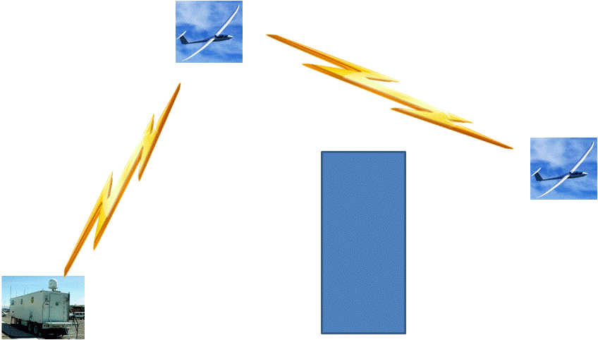
Figure 3: UAV Communication Relay Concept
The primary reason for combine the communications functions with the primary UCATS processor was for reliability. The primary driver for a modular COTS stand-alone Encryption Module was upgradeability. It is anticipated that encryption technology will continue to advance and the upgradeability of a combined radio and encryption function would inhibit the ability to upgrade, and the interfaces modifications needed to upgrade a software-only option would also inhibit upgradeability. Based on current UAV usage, the Receiver/Transmitter would require both SATCOM and LOS communications to communicate with the surveillance UAVs. Ideally, if some of the SATCOM issues can be addressed, the UCATS would switch entirely to SATCOMs; however, until problems such weight, power requirements, bandwidth and packet loss can be corrected, the UCATS Communication Module will require LOS capability. Since the UCATS requires LOS capability, the biggest issue with LOS communications in an urban environment is how to maintain communications when shielded by buildings. A communication relay UAV antenna provided the best solution since it did the best job of maintaining communications, was easily transportable, and easily upgradeable, when compared to the other options.
One benefit of the UAV antenna not addressed in the evaluation is its ability to maintain continuous communications with one of the five available surveillance UAVs, and then maintaining good communications with the other four UAVs. The next step is to conduct the detailed design, which will identify the specific UCATS encryption module, SATCOM and LOS radios, and UAV. However, this is outside the scope of the system level physical instantiation.
APPENDIX A: MAINTAINING COMMUNICATIONS CALCULATIONS

ASSUMPTIONS
- Minimum Pixel Size for a TOI: Per “Automated Target Detection and Tracking for UAV Platforms” by Thomas Loveard and Paul Boxer (Sentient Vision Systems), the minimum pixel size / object is 3 x 3. This algorithm only addresses moving objects and has difficulty with stationary objects. Therefore, to provide some margin of error, assume the minimum pixel size required to track a TOI is 5 x 5.
- UAV Camera Specifications: The capabilities of UAV cameras vary greatly; however, it is assumed that the UAVs tracking the TOIs are medium sized UAVs (wingspan of about 15 feet). This restricts the available payload size. Also, it is assumed that since these are medium sized UAVs, they will not carry the high resolution / high cost cameras used on large and expensive tactical UAVs. Therefore, based on a web search of UAV cameras, we are assuming the field of view is ~51° and the resolution is 1600 x 1200 pixels. Additionally, assume the camera is fixed.
- TOI size: It is assumed the TOIs being tracked are vehicles. Therefore, we assume the average mid-sized car length and width are 16 feet x 6 feet.
- Minimum UAV Altitude: Per “Employing Unmanned Aerial Vehicles (UAVs) as an Element of the Integrated Ocean Observing System”, by A. S. Lomax, W. Corso, and J. F. Etro, the minimum operational altitude of a UAV performing ocean observing missions is 150 meters or 492 feet. Therefore, it is assumed that the minimum altitude used to track TOIs using UAVs is around 500 feet.

UAV Maximum Altitude Calculations

Car Size by Pixels at Highest Tracking Height
- Since the minimum pixel size occurs at maximum height (greatest distance from TOI) we can say the TOI is no smaller than 5 x 5 pixels
- Car dimensions are 16 feet x 6 feet.
- Therefore, to discern an object that is no smaller than 5 x 5, we can assume the pixels correspond to 6 feet/5 pixels or 1.2 feet /pixel. So the average car seen at maximum tracking height is 13.33 x 5 pixels.
- If the resolution is 1600 x 1200, and it is 1.2 feet / pixel, the camera frame is therefore 1,920 feet x 1,440 feet.

Maximum Height Calculations
- Calculating the maximum height is performed using the Figure 1 below:

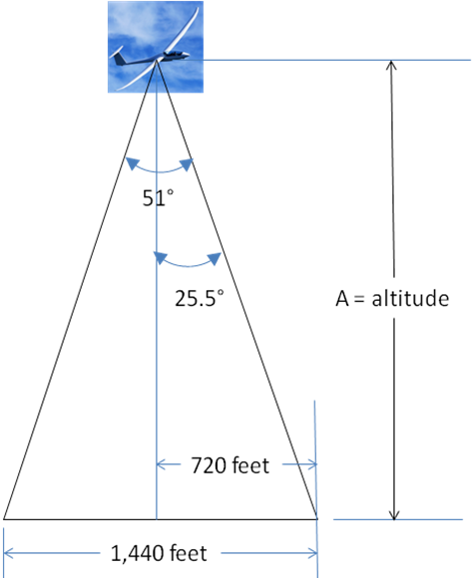
Figure 1: UAV Altitude Calculations

- A = 960 feet/tan 25.5° = 1,510 feet.
- Therefore typical tracking operations will probably range between 500 and 1510 feet in altitude.

Antenna Option Calculations

Tower Antenna
Assumptions:
- The UCATS can be anywhere between 1 mile and 40 miles from the TOI. The 40 mile requirement is directly from the UCATS SRS. It is assumed if the TOI is closer than 1 mile; it can be tracked with optics versus a UAV.
- The UCATS will need to maintain communication with the surveillance UAV throughout its operational altitude envelope of 500 and 1510 feet.GPS Tracking Accuracy: 2 – 5 meter. Therefore, UAVs cannot be closer than 49 feet from a building.
Calculations
Figure 2 describes the ground antenna configuration.
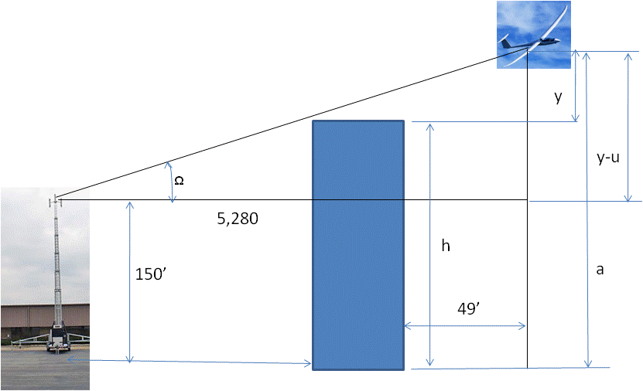
Figure 2: Ground Antenna Configuration
- Worst case conditions for UCATS to UAV communications for the ground antenna configuration, occurs when the UCATS is only 1 mile from the building.
Therefore to determine if the UCATS can communicate with the UAV at the maximum operating altitude:
a = 1510 ft
GPS offset distance = 49 feet
Distance to UAV = 1 mile (5,280 feet)
y-u (antenna height) = 150 feet
tan(Ω) = (1510 – 150)/5280; Ω = tan⁻¹[(1510 – 150)/5280] = 0.25 radians
y = 49 feet * tan(Ω) = 12 feet; h (building height) = 1510 feet – 12 feet = 1498 feet
Therefore, the tower antenna can communicate with UAVs when they are at maximum altitude even if a 900 foot building is in the way.
Therefore to determine if the UCATS can communicate with the UAV at the minimum operating altitude:
a = 500 ft
GPS offset distance = 49 feet
Distance to UAV = 1 mile (5,280 feet)
y-u (antenna height) = 150 feet
tan(Ω) = (500 – 150)/5280; Ω = tan⁻¹[(500 – 150)/5280] = 0.066 radians
y = 49 feet * tan(Ω) = 3.2 feet; h (building height) = 500 feet – 3.2 feet = 496.8 feet.
Therefore, the tower antenna can communicate with UAVs when they are at minimum altitude with buildings 496.8 feet or less in the way.

UAV Antenna
Assumptions:
- Maximum UAV altitude is 5,000 meters (~16,380 feet)
- The Communication relay UAV will need to communicate with UAVs within a 1 mile radius. (Based on Boston Downtown maps, which represent typical cluster of tall buildings)
- GPS Tracking Accuracy: 2 – 5 meter. Therefore, UAVs cannot be closer than 49 feet from a building.
Calculations
Figure 3 describes the ground antenna configuration.
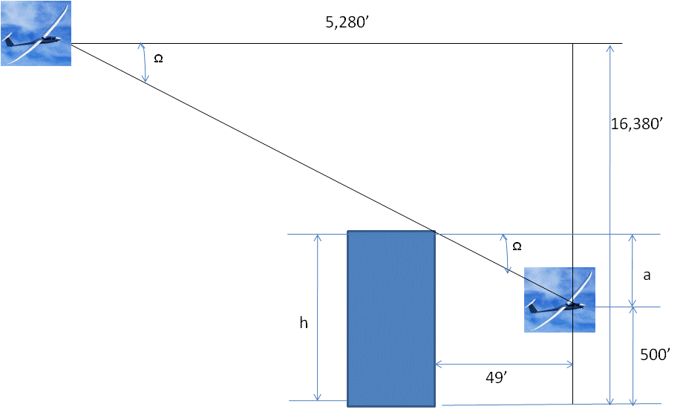
Figure 4: UAV Antenna Configuration
tan(Ω) = (16,380 – 500)/5,280; Ω = tan⁻¹[(16,380 – 500)/13,200] = 1.25 radians
y = 49 feet * tan(Ω) = 147 feet; h (building height) = 500 feet + 147 feet = 647 feet.

Balloon Antenna
Assumptions:
- The UCATS can be anywhere between 1 mile and 40 miles from the TOI. The 40 mile requirement is directly from the UCATS SRS. It is assumed if the TOI is closer than 1 mile; it can be tracked with optics versus a UAV.
- The UCATS will need to maintain communication with the surveillance UAV throughout its operational altitude envelope of 500 and 1510 feet.
- GPS Tracking Accuracy: 2 – 5 meter. Therefore, UAVs cannot be closer than 49 feet from a building.
- Balloon Altitude: 15,000 feet
Calculations
Figure 3 describes the ground antenna configuration.
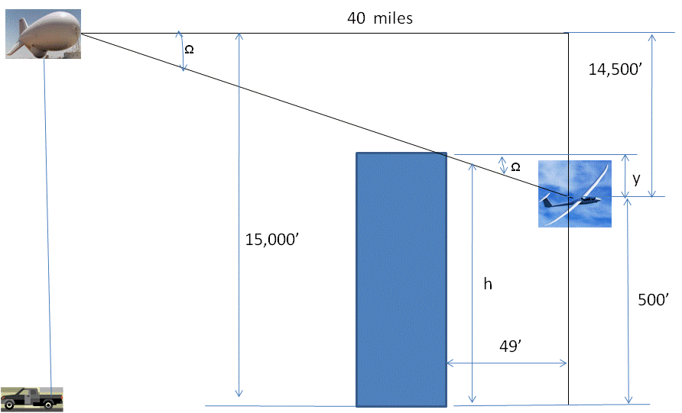
Figure 5: UAV Antenna Configuration
tan(Ω) = (14,500)/(40*5,280); Ω = tan⁻¹[(14,500)/(40*5,280)] = 0.069 radians
y = 49 feet * tan(Ω) = 3.3 feet; h (building height) = 500 feet + 3.3 feet = 503.3 feet.
If the balloon was as close as a mile, using the same equations, the building height would be 634 feet.

“COMM OPS: Trends in Communication Systems For ISR UAVs”, Steve Gardner (GM, Enerdyne Technologies, Inc.), MILSAT Magazine, January 2009 Edition - ISR
“COMM OPS: Trends in Communication Systems For ISR UAVs”, Steve Gardner (GM, Enerdyne Technologies, Inc.), MILSAT Magazine, January 2009 Edition - ISR
“Mobile Satellite Communications - Part 2 A Technical Critique”, Published April, 1997 (Updated 2005), Carlo Kopp
http://www.absoluteastronomy.com/topics/SINCGARS
http://www.bellcommspain.com/Documentos/RADIOS%20TACTICAS/RT-1523.pdf
Per http://en.wikipedia.org/wiki/List_of_tallest_buildings_in_Boston (Boston chosen as typical urban environment)
http://www.cleburnetimesreview.com/local/local_story_142181939.html
http://www.barnardmicrosystems.com/L3_airframes.htm
http://www.insitu.com/documents/redesign09/pdf/ScanEagleFolderInsert.pdf
“Low Cost Wireless Internet Access for Rural Areas using Tethered Aerostats”; P. Bilaye, V. N. Gawande, U. B. Desai, A. Raina, and R. S. Pant
http://www.romdas.com/technical/gps/gps-acc.htm , “HOW IS THE ACCURACY OF A GPS RECEIVER DESCRIBED”, Chuck Gilbert
http://defense-update.com/products/s/scaneagle.htm, “Scan Eagle”, Defense Newsa
http://www.romdas.com/technical/gps/gps-acc.htm , “HOW IS THE ACCURACY OF A GPS RECEIVER DESCRIBED”, Chuck Gilbert
http://www.romdas.com/technical/gps/gps-acc.htm , “HOW IS THE ACCURACY OF A GPS RECEIVER DESCRIBED”, Chuck Gilbert
http://en.wikipedia.org/wiki/Tethered_Aerostat_Radar_System,

